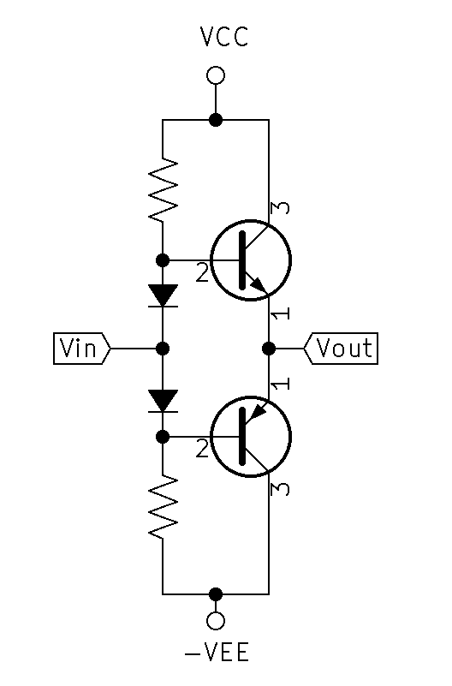

Class AB amplification Characteristics:

* $∆v=1$, $∆i=high$
* High Zin and Low Zout
* Improved efficiency over Class A
${MaxEfficiency}_{classAB}≈50\%$

* Transistors are never on at the same time. Current path is through the load only.
* Transistor Amplification is active for each transistor nearly 180 $°$ of the input cycle (on nearly $50\%$ of the time). This means that nearly 360 $°$ of the input signal is amplified.
* Achieves a high degree of linearity
* Crossover distortion occurs when both transistors are off.

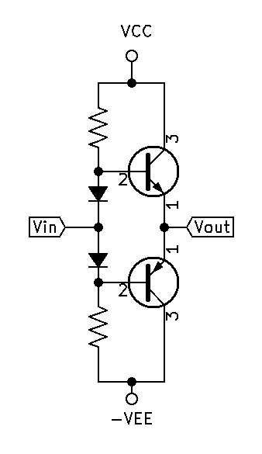

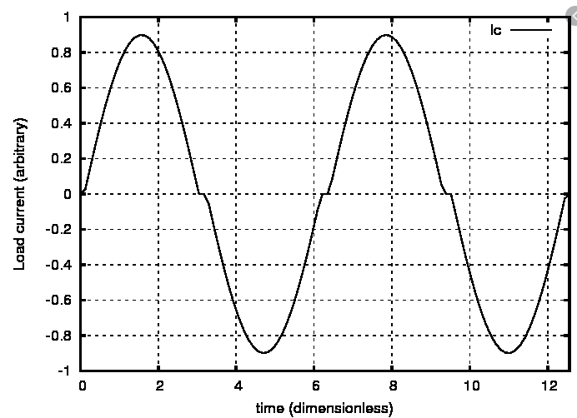

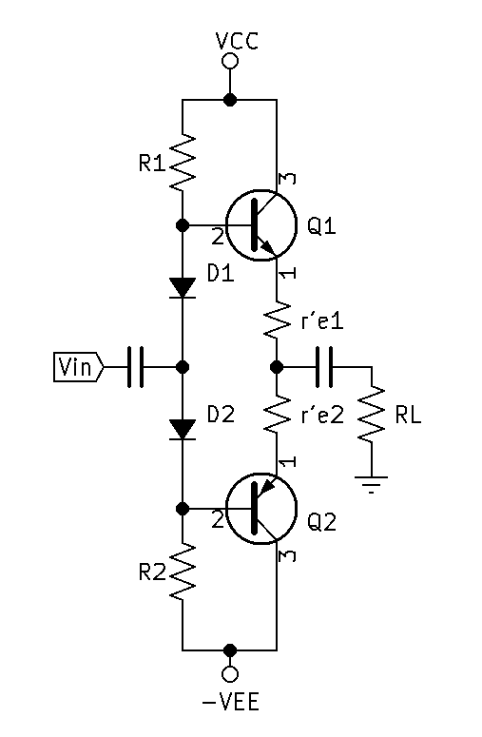**Design:**

$Q1 beta$ $≈Q2 beta$

$Voutmaxp≈\frac{VCC+VEE}{2}$

$Vinmaxp≈Voutmaxp$

${Ie}_{max}≈\frac{Voutmaxp}{RL}$

${Ib}_{max}≈\frac{{Ie}_{max}}{B+1}$

$IR1≥10×{Ib}_{max}$

$VR1=\frac{VCC+VEE}{2}-VD1-VD2$

$R1=\frac{VR1}{IR1}$

$R2=R1$

* Treat as though Q1 is on and Q2 is off. Then find Zin and Zout.

$Zin=[((RL+r^{'}e1)(B+1)//R1)+r^{'}d1]//[r^{'}d2+R2]$

$r^{'}d=\frac{0.026}{I_{F}}$

$Zout=\frac{[Rgen//(r^{'}d2+R2)+r^{'}d1]//R1}{B+1}+r^{'}e1$

**High Power Push-Pull:**

* Follow the previous process, compensate for additional components.

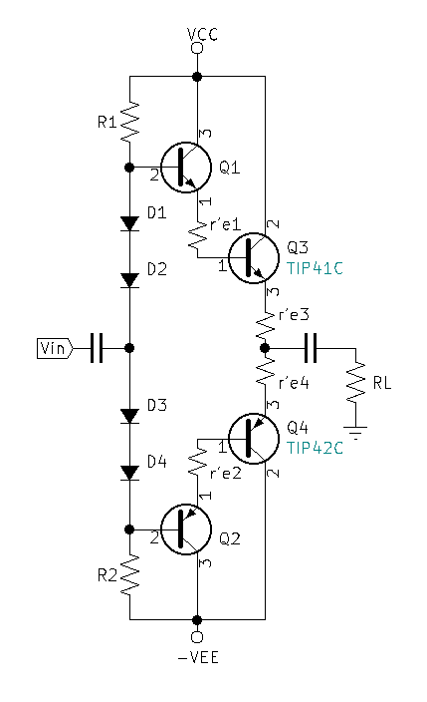

**Shoot-Through:**

* Shoot-Through is a non-desirable condition in which the transistors are conducting current at the same time.
* Shoot-Through can occur due to a voltage bias mismatch between the transistors and the diodes additionally Shoot-Through can be thermally or heat induced.
* 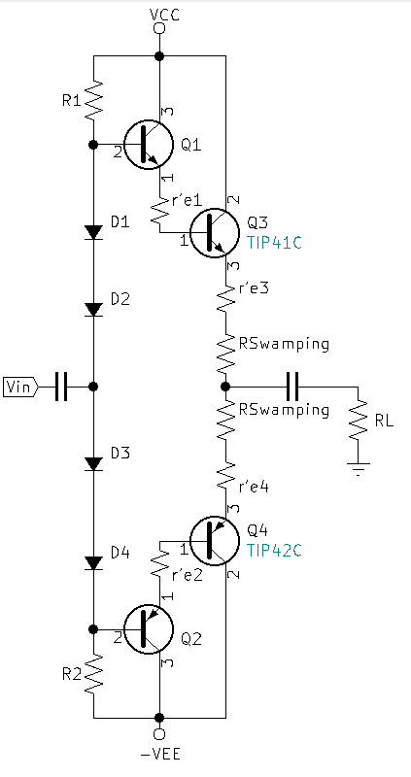Shoot-Through can be eliminated by using a small Swamping Resistor. The larger the Swamping resistor the greater the Cross-Over Distortion will be. Typically 0.1Ω